**

**Mathematics Specialist Unit 2**

# Test 5

**Trigonometric Equations and Number Proofs**

|  |
| --- |
| **Name: ______________________ Total Marks:__________** |
|  |
|  |

**Task type: Response**

**Time allowed for this task:** 60 minutes, in-class, under test conditions

Section One: Calculator-free 27 minutes ( 25 marks)

Section Two: Calculator-assumed 33 minutes ( 31 marks)

**Materials required:** Calculator with CAS capability (to be provided by the student)

**Standard items:** Pens (blue/black preferred), pencils (including coloured), sharpener, correction fluid/tape, eraser, ruler, highlighters

**Special items:**  Drawing instruments, templates, notes on one unfolded sheet of   
A4 paper, and up to three calculators approved for use in the WACE examinations

Formula sheet

**Marks available: 53 marks**

**Task weighting: 7%**

**Section One : Calculator Free 25 Marks**

**Time Allowed 30 minutes**

**Question 1**

**[8 marks]**

1. Match each graph with its corresponding equation below



(i) $y = a tan (x + b)$ Graph ___

(ii) $y = d cos x + e$ Graph ___

(iii) $y = 2 sin cx$ Graph ___

1. Find the values of a, b, c, d and e.

**Question 2**

**[9 marks]**

1. Solve for $x$ in , for $0≤x≤360°$

[2 marks]

1. Solve for $x$ in ${3sec}^{2}{x=}4$ for $0≤x≤2π$

[3 marks]

1. Find all the solutions (in radians) for x in $2\sin\left(x-\frac{π}{2}\right)=-1$

[4 marks]

**Question 3**

**[5 marks]**

Prove that the parity of a cube of an integer is the same as the integer.

**Question 4**

**[3 marks]**

On the grid below sketch the graphs of $y=cosec({x)-1}$

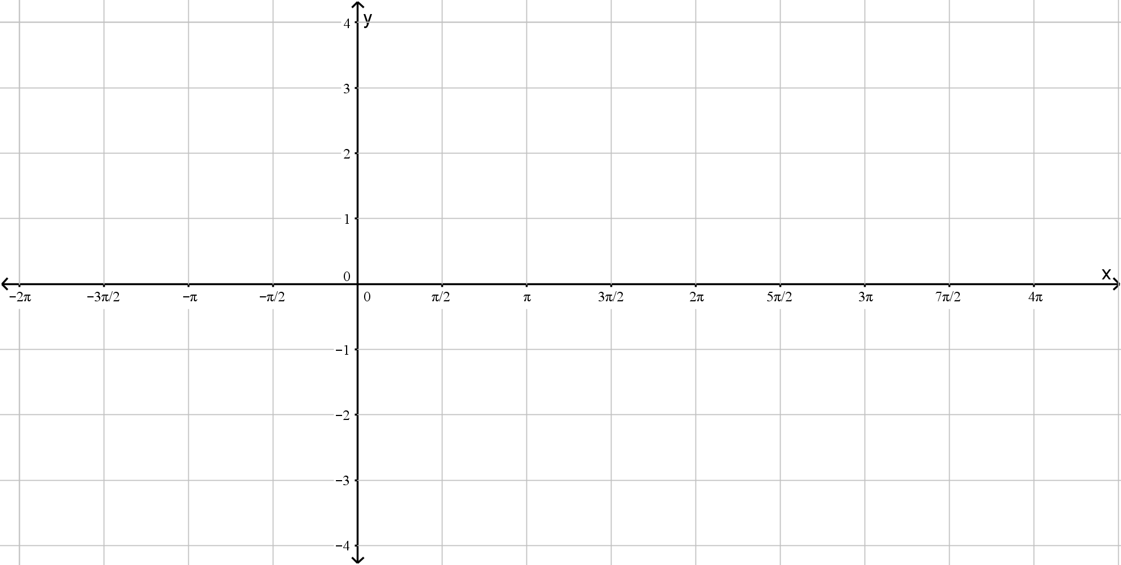

**Section Two : Calculator Assumed 31 Marks**

**Time Allowed 33 minutes Name:_______________________**

**Question 5**

**[3 marks]**

By using trigonometric identities and without the use solely of a calculator, solve for all values of *x* (radians) for .

**Question 6**

**[3 marks]**

Prove that $2.7\overline{4}$ is a rational number.

**Question 7 [ 8 marks]**

1. Express  in the form $y=R\sin\left(θ+α\right)$ where $R>0$ and $0<α<\frac{π}{2}$. Hence find the exact values of $R$ and $α$.

(3 marks)

1. Hence or otherwise sketch the graph of on the axes below.

(2 marks)

1. Find the maximum value of and the values of $x$ at which this occurs.

(3 marks)

**Question 8**

**[7 marks]**

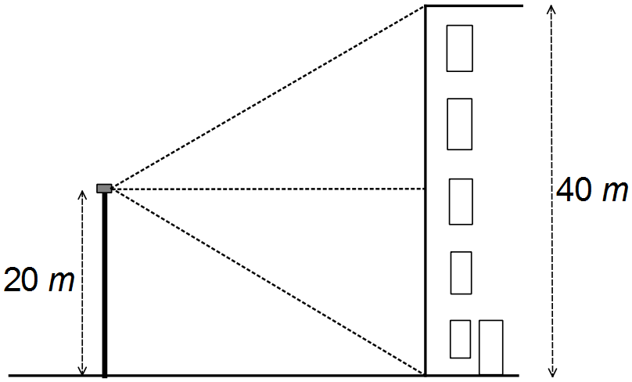

A surveillance motion detector sits on a pole 20 m off the ground and the detection beam moves vertically, shining a laser spot on the wall of a 40 m tall building.

The laser spot takes 30 seconds to move from the base of the building to the rooftop, and 30 seconds to return to the base of the building again. The diagram shown depicts this situation.

a) The graph below depicts the height *h* of the laser spot along the wall for any time *t*.

Complete the graph by clearly labelling the axes.

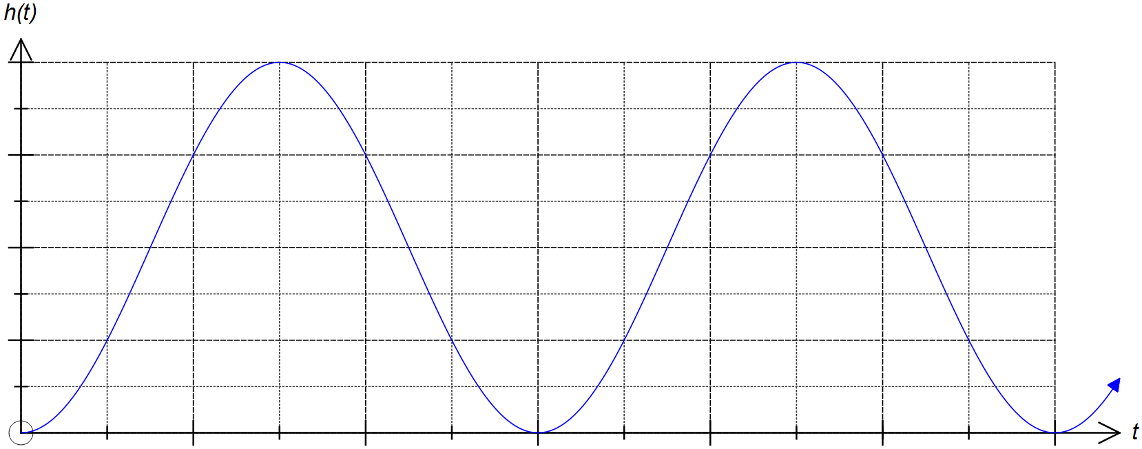

(2 marks)

b) State the equation of *h*(*t*). (3 marks)

c) A burglar 1.8m tall is trying to pick the lock to break in to the building. How long will they have between the laser beam passing to break in without being detected?

(2 marks)

**Question 9**

**[5 marks]**

Use Mathematical induction to prove that  is divisible by 4

**Question 10 [5 marks]**

Prove by contradiction that $\frac{1}{\sqrt{5}}$ is irrational.